Appendix 4
to the Competition Brief
ID No. LPK 2019/1

DESIGNING PROGRAMME

SKETCH DESIGN COMPETITION
Architectural Vision for the Construction
of the Latvian Paralympic Sports Centre

GENERAL INFORMATION
- The Paralympic Committee

The Latvian Paralympic Committee (LPC) is the association responsible for sports for people with disabilities in Latvia aiming to develop and promote the Paralympic movement. Its mission is to ensure the participation of Paralympic athletes in national and international tournaments, and to represent their interests in Latvia and abroad. Currently Paralympic sports include all 28 Paralympic sports as well as non-Paralympic sports and sports adapted for people with mental disabilities and hearing impairment. The Latvian Paralympic Committee is a member of the International and European Paralympic Committee. At present, the Latvian Paralympic Committee is made up of 23 sports federations offering 27 different sports to those who are interested. Each federation also has its clubs in different cities of Latvia, uniting sports and athletes. The Latvian Paralympic Committee also covers the Deaflympics (where deaf and hard-of-hearing athletes compete) and the Special Olympics (for people with intellectual disabilities). At present, the Latvian Paralympic Committee is headed by its president Daiga Dadzīte who organises its work.
- The history of the Paralympic Committee

The Paralympic Movement began in the world in 1948 when neurosurgeon Ludwig Guttmann organised an archery tournament for people with various disabilities. It was the beginning of the Paralympic Movement, which initially developed as rehabilitation for the soldiers wounded in WWII and, continuing to grow, in 1960 it led to the first Paralympic Games in the world history. Adapted sports are divided into Paralympic and non-Paralympic sports. Paralympic adapted sports include archery, track and field, badminton, boccia, canoeing, cycling, goalball, judo, Para powerlifting, rowing, shooting, sitting volleyball, Para swimming, table tennis, teakwondo, triathlon, wheelchair basketball, Para dance sport, wheelchair fencing, wheelchair rugby, wheelchair tennis, biathlon, snowboarding, wheelchair curling, Para hockey, Para alpine skiing, cross-country skiing. Non-Paralympic sports include e.g. sailing and floor hockey.

In Latvia, the origins of Paralympic sport date back to the 1980s. In 1984, Jānis Iluss together with his like-minded peers founded the Nationwide Disabled Sports Club Optimists. For a long time, the club Optimists was one of the largest sports organisations in the Soviet Union uniting people with disabilities. Already in its first year of operation, Optimists had more than 250 participants who organised cultural and sports events in Latvia and abroad and took part in international sports competitions. The first Paralympic sports that developed in Latvia were sitting volleyball, archery and track and field with such disciplines like long jump, shot put and disc throw becoming particularly popular.

The Latvian Paralympic Committee was established on 5 February 1995. From 1995 to 2009, its first president was Valdis Nagobats. Since its establishment in 1995, the Latvian Paralympic Committee has also been linked to the network of the International Paralympic Committee and the European Paralympic Committee. The Latvian Paralympic Committee has had two presidents, namely, Valdis Nagobats (1995–2009) and Daiga Dadzīte (2009–present).

The 1989 World Cup in Athletics was the first official international competition in which Latvian athletes took part, and the first Paralympic Games, in which two Latvian athletes – Aldis Šūpulnieks and Armands Ližbovskis – participated, took place in 1992 in the Spanish capital, Barcelona. As an independent country, Latvia first sent its athletes to the Paralympic Games in 1996, namely, to the Summer Paralympic Games in Atlanta.

Until September 2016, Latvia had been represented altogether in seven Summer Paralympic Games and in two Winter Paralympic Games. The Beijing Paralympic Games in 2008 were the most widely attended ones when 17 athletes from Latvia took part in them and won 3 medals. So far the Rio de Janeiro Summer Paralympic Games in 2016 have been the most successful ones for Latvian Para athletes when 11 athletes took part in 6 different sports, winning 4 medals.

Along with Paralympic sports, adaptive or adapted sports have also developed in Latvia which are not included in the programme of the Paralympic Games but are quite popular. The Latvian Sports Association of the Blind (LNSS) regularly organises tournaments in showdown (a sport where a table resembles a table tennis table and which uses a special ball equipped with sound elements and where participants wear opaque goggles), checkers and chess, and tandem cycling in Latvia. These adaptive sports can also be practised internationally.

3. The major sports organisations for people with disabilities

The Latvian Paralympic Committee (LPC) is today the most significant sports organisation for people with disabilities in Latvia.

The Latvian Sports Association of the Blind (LNSS) organises sports and leisure activities for people with various vision impairments. This is an independent sports organisation, a society that unites Latvian sports clubs and associations of the blind on a voluntary basis. The LNSS is a member of the Latvian Paralympic Committee and the International Blind Sports Federation (IBSA).

The Latvian Sports Federation of the Deaf (LNSF) is an independent sports organisation, an association responsible for sports for people with hearing impairments. The LNSF was registered on 2 February 2006, and on 11 August 2010 it was officially recognised as a sports organisation. The LNSF is a member of the Latvian Paralympic Committee and the International Committee of Sports for the Deaf (ICSD). It is the most important organisation in Latvia covering all kinds of adaptive sports for people with hearing impairments, e.g. chess, swimming, bowling. The Latvian Sports Federation of the Deaf organises participation of athletes in the Deaflympics.

The Latvian Sports Federation of Children and Young People with Disabilities (LBJISF) was founded in 1993. This organisation is responsible for promoting adaptive sports for children with different disabilities. It has more than 40 members. The aim of this organisation is to facilitate improvement of children and youth’s physical and mental health and encourage their engagement in public life, using Paralympic and adaptive sports as a means for achieving this aim. The LBJISF has also established a training centre called A Sports that regularly organises various specialised courses of continuing education and seminars for professionals wishing to specialise in work with young people with disabilities. Aija Kļavina is currently the president of the LBJISF. The LBJISF is a member of the Latvian Paralympic Committee.

The most important internet resources.
1. The website of the Latvian Paralympic Committee: http://www.lpkomiteja.lv.
2. The website of the Latvian Sports Federation of Children and Young People with Disabilities: http://www.asports.lv
3. The website of Latvian sitting volleyball: http://sedvolejbols.lv/
4. The website of the Latvian Sports Association of the Blind: http://lnssinfo.lv/lv/par-mums.html
5. The website of the Latvian Sports Federation of the Deaf: http://lnsf.lv/
6. The website of the Latvian wheelchair basketball: http://www.ratinbasketbols.lv/
7. The website of the informative resource “Aktīvs.org”: http://www.aktivs.org/

4. THE STRATEGY OF THE LATVIAN PARALYMPIC CENTRE
It is planned that the Paralympic Sports Centre will be a modern multifunctional sports centre for people with special needs having the infrastructure appropriate for various sports in Riga, in Bišumuiža neighbourhood in Zemgale suburb between Gulbju and Padures Streets and on both sides of Ceraukstes iela.
By building the Paralympic Sports Centre in Bišumuiža neighbourhood, it is planned to attract more visitors to sports events of various scale, thus also contributing to the increase of the population flow in the neighbourhood and improvement of the social and economic environment.
The following facilities will be located in the Paralympic Sports Centre:
1. Multifunctional sports hall with accommodation and sports laboratory.
2. Curling Hall.
3. Beach volleyball courts.
4. Basketball court with stands.
5. Stadium for track and field competitions and football matches complying with the IAAF Construction Category III requirements and the LFF Category II requirements. The stadium will include stands with 1600 spectator seats and a block of locker rooms and auxiliary facilities built below them.
6. Track and field warm-up stadium complying with the IAAF Construction Category III requirements.
7. Tennis courts with a maintenance building.
8. Parking spaces next to each building and a group of buildings.

The functional organisation and landscaping of the Sketch Design competition territory should include demolition of buildings degrading the environment and reconstruction or conversion of buildings of cultural and historical value, as well as establishing of infrastructure which complies with modern standards and satisfies the needs of various sports. It is intended to build the object in stages.

The Sketch Design will be used as a basis for elaboration of a construction design.
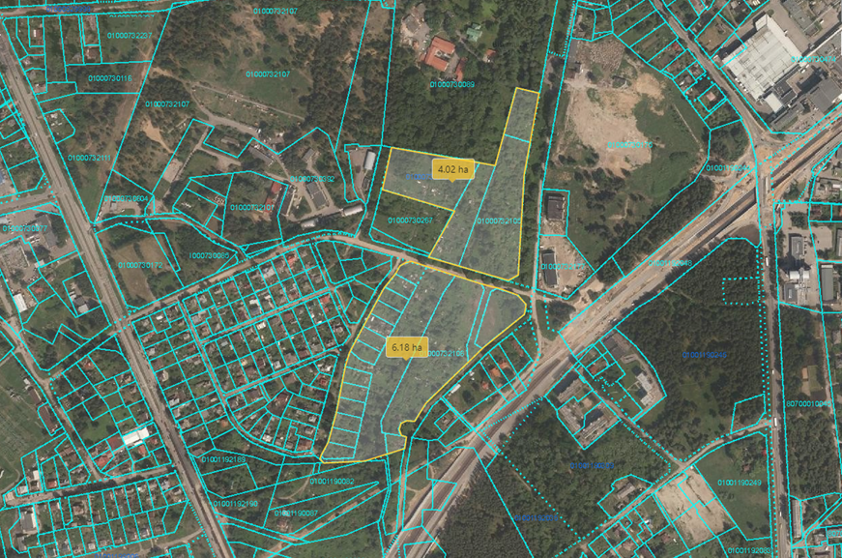

Borders of the Sketch Design competition territory
5. The Sketch Design competition territory:
The territory of the Sketch Design competition is located in the southern part of Riga, on the left riverbank of the Daugava, in Bišumuiža neighbourhood of Zemgale suburb and it includes plots of land at Padures iela 32, 34, 36, 38, 40, 42, 44, 46, 48, 50, 52, 52A, 54, a plot of land in Ceraukstes iela with cadastral No. 01001192029, a plot of land at Gulbju iela 9A, plots of land at Ceraukstes iela 27, 29, 48, 50 and plots of land with cadastral Nos. 01000730121 and 01000730171.
The area of ​​the planned object slightly exceeds 10 ha. Currently, the Commissioner owns three plots of land of the aforementioned ones, i.e. at Ceraukstes iela 29, 48 and 50. Considering the fact that the other plots of land belong to the Municipality of Riga, the Commissioner will settle the issues related to the real estate ownership before commencing the implementation of the development vision for the territory in order to be able use these plots of land according to the intention and idea.
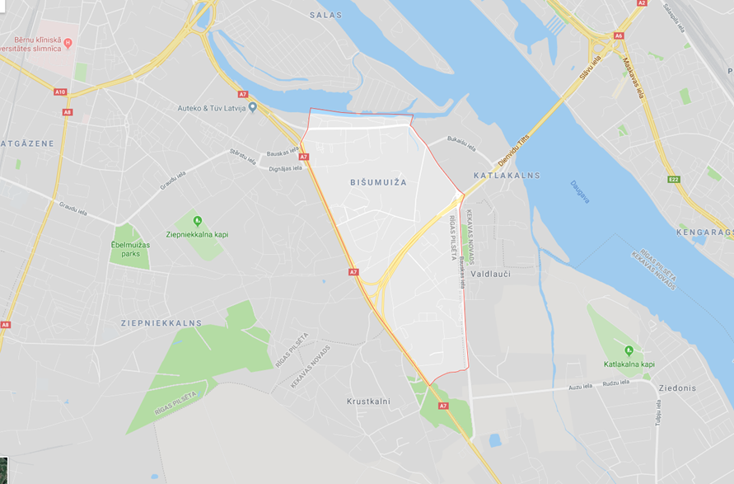

The study area of the Sketch Design competition includes the urban area with adjacent streets, infrastructure and buildings

The coordinates of the competition territory are as follows:
The Bieķengrāvis Ditch in the north - 56°55'02.8"N 24°07'26.9"E
The Bieķengrāvis Ditch in the north - 56°55'01.0"N 24°08'21.2"E
The Southern Bridge in the east - 56°54'37.7"N 24°08'49.1"E
Valdlauči in the south - 56°53'47.4"N 24°08'50.7"E
Ziepniekkalna iela in the south - 56°53'47.4"N 24°08'50.7"E
Bauskas iela in the west - 56°54'52.6"N 24°07'20.8"
6. Description of the study area of the Sketch Design competition
The territory of the Sketch Design competition is located in the southern part of Riga, on the left riverbank of the Daugava, in Bišumuiža neighbourhood of Zemgale suburb. The neighbourhood borders are: the Bišumuiža Ditch, Bauskas iela, a city border, Ziepniekkalna iela, Bauskas iela, Doles iela. The total area of ​​Bišumuiža neighbourhood is 224.3 ha. Outside the Daugava Valley, the entire territory of Bišumuiža neighbourhood is a rolling plain with small dune hills. Apart from the area of ​​the neighbourhood adjoining the Bieķengrāvis, the central and southern parts of the neighbourhood are relatively flattest where the elevation reaches 8-10 m above sea level. Meanwhile, the most undulating terrain in Bišumuiža is located in the northern part of the neighbourhood near the Daugava Valley (the so-called Ziepniekkalns dunes) where the height difference varies from 4 to 16 m.
Engineering and geological conditions are very varied in Bišumuiža neighbourhood. In the northern part of the Daugava Valley, engineering and geological conditions are unfavourable for construction. The upper layer there consists of loose sand of varying coarseness with 1-3m to 6-8m thick layers of silt. In the built-up areas, natural soils have been replaced with a layer of fill several meters thick. There are also high groundwater levels (shallower than 1.5 m) in this territory. Complicated construction conditions are also found in the areas around the Bišumuiža Ditch intersecting Bišumuiža neighbourhood from NE to SW. Groundwater levels are also high there, and the sand layers above the bedrock are rich in organic matter (peat and mud).
Conditions are mostly favourable for construction in Ziepniekkalns dune areas in Bišumuiža neighbourhood with groundwater levels exceeding 1.5 m. Besides, conditions that are also favourable for construction exist in the central part of the western area of the neighbourhood. In these areas the upper layer is composed of fine sand interspersed with moderately compacted layers of medium to coarse sand.
The Bieķengrāvis Ditch adjoins the neighbourhood and the Bišumuiža Ditch flows through it. The Bieķengrāvis Ditch is the left outflowing branch of the River Daugava starting at Zaķusala and falling into the Little Daugava. The hydrological importance of the Bieķengrāvis Ditch is gradually diminishing as it keeps increasingly overgrowing. The Bišumuiža Ditch flowing from the side of Ķekava civil parish falls into the Bieķengrāvis Ditch that intersects the entire neighbourhood of Bišumuiža from SW to NW. This ditch formed as a result of confluence of several drainage ditches flowing out of Baloži peat bog. The Bišumuiža Ditch drains not only Bišumuiža neighbourhood, but also part of Ziepniekkalns neighbourhood and the northern part of Ķekava civil parish.
Nature and greenery areas occupy 24% or 54.7 ha in Bišumuiža, but none of them is specially protected. The largest ones of these nature and greenery areas are concentrated around the Bišumuiža Ditch, as well as in the southern part of the neighbourhood around the Southern Bridge. In the territories around the Bišumuiža Ditch, nature and greenery areas are mostly used as kitchen gardens, while the southern part of the neighbourhood is covered with forests or groves.

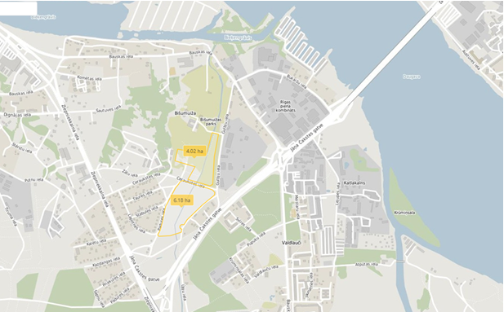Areas of residential and detached houses account for 29% of the built-up area in the neighbourhood. Mixed built-up areas cover approximately 17% of the neighbourhood. They are mostly located in the industrial territories at Bauskas iela and Ceraukstes iela, as well as in several places at Ziepniekkalna iela. Roads and streets occupy 18% or 40 ha of the area in ​​Bišumuiža neighbourhood. As a result of the construction of the Southern Bridge and its connection to Bauskas and Ziepniekkalna Streets the neighbourhood has become more accessible.
The street network in Bišumuiža is poorly developed, but it is adequate for the nature of the existing built-up area. Ziepniekkalna iela runs along the western part of the neighbourhood and together with Bauskas iela (local street) they provide the main links to other areas. Significant changes in the spatial structure and accessibility of the neighbourhood have taken place after the construction of the Southern Bridge, which being a highway, has improved the links of the neighbourhood with the territories on the right riverbank of the Daugava.
Bišumuiža can be accessed by public transport quite well. All public transport routes intersecting the neighbourhood connect it to the city centre and other neighbourhoods on the right bank of the Daugava, while Tram 10 allows getting easily to the junction where commuters can easily switch from one transportation mode to another in order to reach most of the neighbourhoods on the left bank of the Daugava.
7. Description of the territory of the Sketch Design competition
The area where the Sketch Design competition is to be held is mostly flat. It is located on lowland with a marked elevation at the north-western side of the territory. The territory is intersected by the Bišumuiža Ditch that is the former stream of Katlakalns Watermill or the Bišumuiža River (12 km long and meandering) which used to flow from Baloži peat bog, meander through the centre of Bišumuiža, falling into the upper part of the Bieķengrāvis Ditch near Kaza Sandbank.
Currently, the territory of the Sketch Design competition is mostly vacant, with small garden sheds scattered here and there. The territory gradually begins to overgrow. In the north it borders on the territory of Bišumuiža, in the northeast and northwest – on industrial buildings, in the southwest, in the south and southeast – on residential buildings.
8. HISTORICAL DESCRIPTION OF THE TERRITORY OF THE SKETCH DESIGN COMPETITION AND THE STUDY AREA
Bišumuiža is a historical neighbourhood of Riga. Its formation began around Bee Manor (in German Bienenhof) built in 1773, previously also known as Schilderhof Manor or Hilsenhof Manor being named after their owners. The first owner of Bišumuiža was Anna Kathrin Schilder, born von Ramma, who looked after Johann Gottfried Miettel, the outstanding composer and organist at St Peter’s Church, who spent the rest of his life in Bišumuiža. In 1784, the estate was inherited by her son Heinrich Schilder and later by her grandson Michael Schilder.
In 1786, the manor was bought at an open auction by Friedrich Hilzen, a merchant of the Riga Great Guild. Around 1810, Bišumuiža Manor was purchased by Jacob Johann Brandenburg who built the existing classicist lord’s house of the manor in the 1820s and began establishing Bišumuiža Park around the same time.
In 1828, it was first marked in the plan of Riga as a part of the city. In the mid-19th century, the territory of the manor was expanded, the old building of Jacob’s Mill or Jacob’s Heights was converted into an oil factory, and a ribbon factory was built on a plot at Bauskas iela. All these properties collectively became known as Bišumuiža, while the place name “Katlakalns”, which was used earlier, was applied to an increasingly smaller area.
In 1871, Brandenburg oil factory was bought by Gummal Gustav Knopp who established Knopp paper mill in its place. In 1874, Jacob’s Heights and the ribbon factory were acquired by Riga’s merchants Karl Beythien and Johann Schmidt. The ribbon factory and the paper mill operated until WWI.
In the 1900s, a factory of safety-matches Vulkāns was built in Bišumuiža. As manufacturing kept developing, the population of Bišumuiža grew and social life became more active. In the early 20th century, the manor belonged to Hebenstreit and Grass, later it was inherited by Hebenstreit’s heirs who formally were its owners until the late 1920s. During WWI, the owners left the manor and the building was uninhabited for some time.
In the 1920s, after the establishment of the Republic of Latvia, the former lord’s house of the manor belonged to the housing cooperative Mans nams, and in 1928 it was included on the list of cultural monuments. The cooperative failed to repay its mortgage on time, and in the late 1930s the house was auctioned. After WWII, in the 1950s, administrative offices of the factory Rīgas stikls were set up in the manor house, while its auxiliary buildings were used as warehouses.

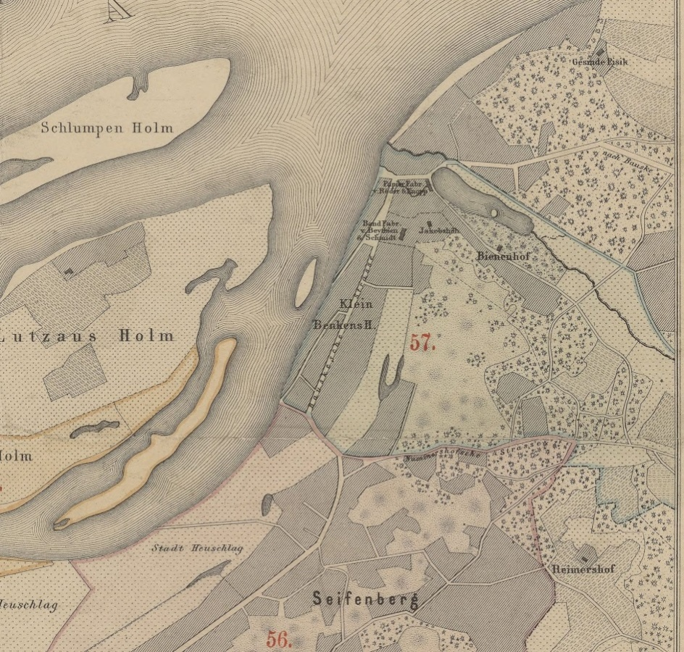
Map of Bišumuiža (Bienenhof) neighbourhood, 1876
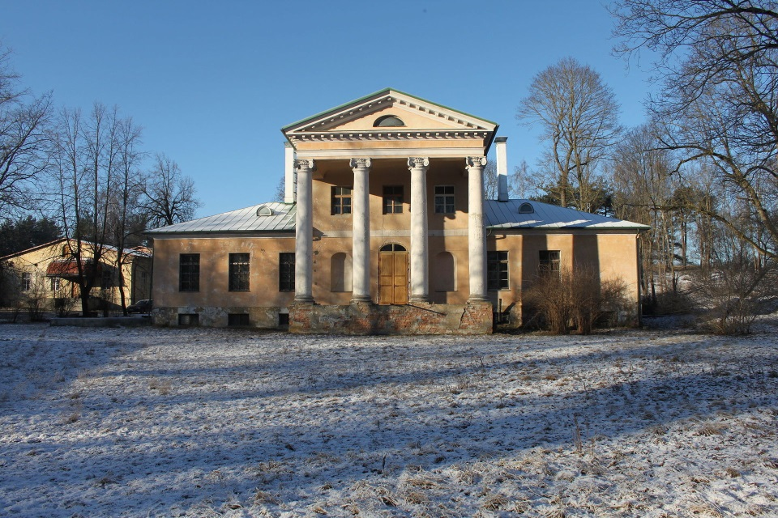
Lord’s house of Bišumuiža Manor, built in 1820

9. DESCRIPTION OF THE URBAN ENVIRONMENT IN THE COMPETITION
TERRITORY
The territory of the Sketch Design competition is located in the southern part of Riga, on the left riverbank of the Daugava, in Bišumuiža neighbourhood of Zemgale suburb. The competition territory consists of two independent zones separated by Ceraukstes iela (street) that divides it into northern and southern parts. Ceraukstes iela and the Bišumuiža Ditch, intersecting the territory from north to south, are two distinctly linear elements organising the urban environment. The trees growing in the competition territory are one of the greatest values of this area.
The end stop of Tram 10 and the stop Bišumuiža of Bus 23 are located in the north of the competition territory, at the intersection of Bauskas and Bukaišu Streets. In SW of the competition territory there is a stop Kalētu iela of Buses 26 and 60 and in the east, in Jāņa Čakstes gatve (street), there is a stop Lejupes iela of Buses 12 and 60.
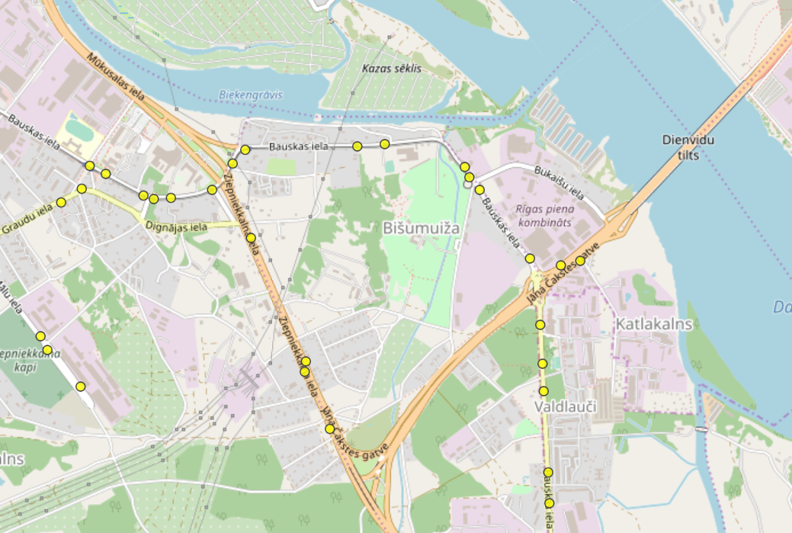
Public transport stops in the vicinity of the competition territory
According to the Spatial Plan in force, a protective zone of Bišumuiža and Manor Park is partly located in the northern part of the planned Sketch Design territory, this zone is intersected by the boundary of accidental flooding of the Daugava HPP. Besides, as regards its function, the planned object contradicts the currently valid Riga City Spatial Plan.
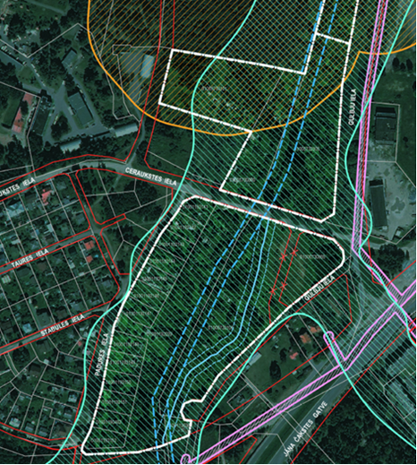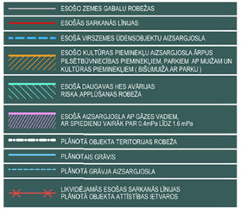
Encumbrances existing in the territory of the Sketch Design competition
Before the elaboration of the construction design, it is planned to carry out an appropriate procedure in order to change a type of use that is currently determined for the competition territory and to rearrange the borders of the plots of land. In accordance with the procedure prescribed by laws and regulations the ministry of the relevant sector is entitled to forward a proposal for identification of objects of national interest under Section 17 of the Law on Spatial Development Planning.
10. PROJECT IDEA OF THE SKETCH DESIGN COMPETITION
The development vision must include master plan solutions for the Sketch Design territory, functional and architectural solutions for the Paralympic Sports Centre so that it could function according to the specific requirements of its profile and create an urban environment of high aesthetic and landscape value.
The main organising elements of the territory are Ceraukstes iela and the Bišumuiža Ditch. The current location of the Bišumuiža Ditch completely prevents arrangement of buildings and structures needed for the Paralympic Sports Centre in the territory. As part of the planning, it is recommended to change the geographic location of the ditch in the project territory, creating a visual character and landscape of a natural watercourse for the new water body establishing a pedestrian and cyclist path with recreational areas and ornamental plantations of greenery along it. In order to interconnect the territory and ensure logical movement not only for pedestrians but also for vehicles, crossings e.g. footbridges and bridges should be planned at certain points across the ditch and culverts should be installed where necessary.
The trees growing in the competition territory are one of the greatest scenic values of this area. When designing new buildings, existing trees should be respected and retained as much as possible, and their groups will create visually a sense of an appealing green space.
It is intended to implement the development vision of the planned object in several construction stages.
The following facilities will be located in the northern part of the territory:
- the multifunctional sports hall with accommodation and sports laboratory. It is planned to have wheelchair basketball, 3x3 wheelchair basketball, sitting volleyball, floorball, boccia, table tennis, powerlifting in the multifunctional hall, and provide the track and field running track for long jump, running and archery;
- Curling Hall.
- Beach volleyball courts (sitting volleyball in sand, sand volleyball).
- Basketball court (wheelchair basketball, 3x3 basketball) with stands.

In the southern part of the territory, on the other side of Ceraukstes iela, it is planned to have:
- The stadium for track and field competitions and football matches complying with IAAF Construction Category III requirements and LFF Category II requirements. The following Paralympic sports are planned in the stadium: shot put, javelin throw, disc throw, long jump, running. The stadium will include stands with 1600 spectator seats and a block of locker rooms and auxiliary facilities built below them.
- the track and field warm-up stadium complying with IAAF Construction Category III requirements.
- tennis courts with a maintenance building.
There will be a car park next to each group of buildings and structures.

As part of the implementation of the planned object, it is planned to liquidate the prospective street with its street lines located between the plots of land with Nos. 01000730065 and 01000732106 and connecting Gulbju and Ceraukstes Streets. In the southern part of the territory, it is planned to change the location of the existing Bišumuiža Ditch in order to arrange the necessary buildings and structures in the territory and create a logical link between them.

11. REQUIRED SPACES

No. | Purpose of use | Room area m²/number | Notes
- MULTIFUNCTIONAL SPORTS HALL WITH ACCOMMODATION AND SPORTS LABORATORY
1.1. | Group of sports lobby rooms:
 | lobby with an administrator’s desk and a transformable cloakroom area | 300.00 m²
 | administrator's office space | 10.00-12.00 m²
 | commercial space, including café | 30.00 m²
 | security control room | 12.00 m²
 | juice bar can be combined with a café | 20.00 m²
 | press conference hall/classroom | 30.00 m²
 | wheelchair room with repair area | 50.00 m²
 | women's toilets: 10 toilet bowls, 4 sinks. | 60.00 m² | Evenly distributed toilet facilities that can be easily accessed from different parts of the building. Toilets must comply with requirements for environmental accessibility
 | men's toilets: 8 toilet bowls, 4 urinals, 4 sinks. | 60.00 m²
1.2. | Group of sports rooms
1.2.1. | Sports hall 45.0 x 38.0 m,  - basketball court 34 x 19m, during competitions min. distance to stands 5m, ceiling height 12.5m,  - volleyball court 40 x 24m,  - floorball 44 x 22 m |  | FIBA certified hardwood (Canadian maple) sports floor, other sports flooring - synthetic, e.g. Teraflex or analogue
 | doctor's office, first aid room | 20.00 m²
 | storage room for bulky equipment | 60.00 m²
 | storage room for sports equipment | 30.00 m²
 | storage room for cleaning equipment of sports hall floor | 10.00 m²
zone of transformable stands with a possibility to provide 1200 standard seats, there should be a spectator area for wheelchair users.
there should be 50 seats for wheelchair users and their assistants in transformable stands
1.2.2. | Running track 7 x 86m, including 4 lanes 60m long with start and finish safety zone, long jump pit (2x6m) with a run-up zone on the track.  Running track can be adjusted to archery needs, taking into account the necessary safety measures | 602.00 m² | IAAF certified synthetic flooring for track and field sectors and running tracks
 | storage room for track and field equipment | 20.00 m²
 | athlete locker room with lockers, 2 toilets, 4 showers, sauna, massage table, coach’s table, doctor’s table, tactics board, 2 x 85.00 m² | 170.00 m²
 | athlete locker room with 20 lockers, 2 toilets, 4 showers, 4 x 45.00 m² | 180.00 m²
 | coach/referee locker room with 10 lockers, 1 toilet, 2 showers | 30.00 m²
 | doping control rooms | 25.00 m²
 | room for storage of cleaning equipment | 10.00 m²
1.3. | fitness facilities, gyms
 | fitness hall | 140.00 m² | shock absorbing, sound-absorbing synthetic flooring
 | room for storage of fitness hall equipment | 10.00 m²
 | gym | 120.00 m² | sports floor FLEX or equivalent
 | room for storage of gym equipment | 15.00 m²
 | men’s locker room with 20 lockers, 1 toilet, 4 showers | 45.00 m²
 | women’s locker room with 20 lockers, 1 toilet, 4 showers | 45.00 m²
 | room for storage of cleaning equipment | 10.00 m²
1.4. | Group of auxiliary rooms of sports section
 | office of hall’s administration, 2 x 20.00 m² | 40.00 m²
 | staff locker room with a toilet and a shower | 20.00 m²
 | staff room with a kitchen niche | 20.00 m²
 | room for storage of territory cleaning equipment | 20.00 m²
 | technical rooms: power distribution, server room, ventilation chambers, water inlet room, heating unit. | m²
 | Lifts, ramps, corridors, stairs (~ 15%) |  | Dimensions of lift cabin no less than 1.5 x 2.65 m
- ACCOMMODATION WITH OFFICES AND SPORTS LABORATORY
2.1. | Group of accommodation facilities
 | lobby with a reception desk | 200.00 m²
 | reception office space | 12.00 m²
 | bar | 45.00 m²
 | bar’s auxiliary room | 10.00 m²
 | restaurant with 70 seats | 160.00 m²
 | restaurant kitchen with auxiliary rooms | 200.00 m²
 | commercial space | 25.00 m²
 | conference hall with transformable acoustic partitions, divided into 3 parts | 300.00 m²
 | auxiliary room of a conference hall | 45.00 m²
 | women's toilets: 3 toilet bowls, 2 sinks | 20.00 m² | Toilets must comply with requirements for environmental accessibility
 | men's toilets: 2 toilet bowls, 1 urinal, 2 sinks | 20.00 m² | Toilets must comply with requirements for environmental accessibility
 | luggage storage room | 20.00 m²
 | accommodation administrator’s office, 2 x 15.00 m² | 30.00 m²
 | linen storage room | 15.00 m²
 | room for storage of household chemicals | 15.00 m²
 | staff locker room, toilet, shower, 2 x 20 m² | 40.00 m²
 | staff room with a kitchen niche | 20.00 m²
 | room for storage of lobby area cleaning equipment | 6.00 m²
 | twin room accommodation, 76 x 30.00 m² | 2280.00 m²
 | deluxe accommodation, double room 10 x 45.00 m² | 450.00 m²
 | corridors with niches at rooms for placing and charging of electric wheelchairs | 760.00 m²
 | equipment room, auxiliary room, 4 x 10.00 m² | 40.00 m²
 | corridors, stairs, lifts of the group of spaces incl. accommodation, offices and lobby of sports laboratory (~ 10%) |  | Dimensions of lift cabin no less than 1.5 x 2.65 m
2.2. | Group of office spaces
 | reception room, secretary’s office | 30.00 m²
 | conference room | 25.00 m²
 | room for 3 employees in wheelchairs, including a couch | m²
 | open-plan office with 5 workplaces | 60.00 m²
 | women’s toilet: 1 toilet bowl, 1 sink. | m² | Toilets must comply with requirements for environmental accessibility
 | men’s toilet: 1 toilet bowl, 1 sink. | m² | Toilets must comply with requirements for environmental accessibility
 | room for storage of cleaning equipment | 6.00 m²
 | corridors, stairs, lifts (~ 10%)
2.3. | Group of medical facilities (sports laboratory)
 | lobby with a reception desk | 20.00 m²
 | reception office space | 12.00 m²
 | doctor’s office | 20.00 m²
 | archives | 4.00 m²
 | women’s toilet, 1 toilet bowl, 1 sink | m² | Toilets must comply with requirements for environmental accessibility
 | men’s toilet, 1 toilet bowl, 1 sink | m² | Toilets must comply with requirements for environmental accessibility
 | diagnostics room | 30.00 m²
 | physio room, 2 x 20.00 m² | 40.00 m²
 | gym, hall with special fitness equipment | 30.00 m²
 | sports laboratory with diagnostics and analysis equipment 8 x 10 m | 80.00 m²
 | visitor locker room with 5 lockers, 3 showers, 1 toilet, 2 x 20.00 m² | 40.00 m²
 | staff locker room with a shower and a toilet | 20.00 m²
 | staff room with a kitchen niche | 15.00 m²
 | material, linen storage room | 8.00 m²
 | room for storage of room cleaning equipment | 5.00 m²
 | corridors, stairs, lifts (~ 15%)
2.4. | Group of accommodation auxiliary rooms
 | room for storage of territory cleaning equipment | 20.00 m²
 | technical rooms: power distribution, server room, ventilation chambers, water inlet room, heating unit. Solutions for location of technical systems, indicating rooms and areas required for them must be proposed as part of the Sketch Design competition. | m²
- CURLING HALL
 | Curling ice arena with 4 curling sheets, area 30.0 x 54.0 m, size of curling sheet 4.75x44.51m, ceiling height 5-6m | 1620.00 m²
 | spectator stands with 400 seats (one spectator seat 0.5x0.85m), including 60 seats for people with disabilities (1.2x0.9m) and their assistants | 580.00 m²
 | lobby with information area and administrator’s desk | 100.00 m²
 | technical room for ice preparation | 30-50.00 m²
 | administrator’s office space | 12.00 m²
 | women’s toilet, 5 toilet bowls, 2 sinks | 40.00 m² | Toilets must comply with requirements for environmental accessibility
 | men’s toilet: 3 toilet bowls, 2 urinals, 2 sinks | 40.00 m² | Toilets must comply with requirements for environmental accessibility
 | doctor’s office | 15.00 m2
 | security control room | 8.00 m²
 | wheelchair room | 30.00 m²
 | café area overlooking the ice arena with 60 seats | 120.00 m²
 | kitchen with auxiliary rooms | 40.00 m²
 | locker rooms with 20 lockers, 2 toilets, 4 showers, 2 x 45.00 m² | 90.00 m²
 | locker rooms with 10 lockers, 1 toilet, 2 showers, 2 x 45.00 m² | 90.00 m²
 | shower room for visitors of outdoor basketball, beach volleyball courts, 4 showers | 20.00 m²
 | toilet for visitors of outdoor basketball, beach volleyball courts, 2 toilet bowls | 10.00 m²
 | staff room | 20.00 m²
 | equipment room | 30.00 m²
 | room for outdoor basketball and beach volleyball equipment (entrance from the outside) | 40.00 m²
 | room for storage of cleaning equipment | 15.00 m²
 | technical rooms: power distribution, server room, ventilation chambers, water inlet room, heating unit, ice preparation room. Solutions for location of technical systems, including rooms and areas required for them, must be proposed as part of the Sketch Design competition. | m²
 | corridors, stairs, lifts (~ 10%)
4. | EXTERNAL STANDS WITH 1600 SEATS AND LOCKERS AND AUXILIARY ROOMS
4.1. | Stadium of track and field competitions and football matches
complying with
IAAF Construction Category III requirements and LFF Category II requirements
4.2. | Stands for 1600 spectators, including:
VIP seats in stands, 100 seats,
(one seat 0.5x0.85m, a seat for a spectator with special needs 1.2x0.9m)
 | seats for media (0.75x1.2m) in stands, 20 seats, including 10 seats with tables (1.5x1.6m).
 | commentator’s booth, min. 1 seat with separate high speed internet connection
 | seats for TV and radio commentators, 3 seats
 | Main TV platform for 2 cameras (min. 2x2m for one camera). Min. 6 m², located as close as possible to the centre of stands, on podium.
4.3. | Lockers and auxiliary rooms
 | TV studio zone, min. 1 piece, 5x5, h 2.3 m | 25.00 m²
 | lobby for athletes | 100.00 m²
 | information area with an administrator’s desk | 6.00 m2
 | administrator’s office space | 8.00 m²
 | security control room | 8.00 m²
 | wheelchair room | 30.00 m²
 | women’s toilet: 1 toilet bowl, 1 sink | 5.00 m²
 | men’s toilet: 1 toilet bowl, 1 sink | 5.00 m²
 | first aid room for players, officials (visible or with a clear indication of its location) | 15.00 m²
 | first aid room for spectators (visible or with a clear indication of its location) | 15.00 m²
 | track and field locker room with 60 lockers, massage room, sauna, 8 showers, 3 toilets, 2 x 230.00 m² | 260.00 m²
 | footballer locker room with 25 lockers, massage room, 5 showers, 3 toilets, tactics board, 2 x 50.00 m² | 100.00 m²
 | referee locker room for 5 persons, 3 showers, 1 toilet, tactics board 2 x 20.00 m² | 40.00 m²
 | delegate’s room/massage room | 12.00 m² | Telephone, fax, internet, table, chair. Easy access to players’, referee’s locker rooms
 | doping control (waiting room ~ 15 m², waiting room approx. 20 m², shower, toilet min. 5.00m²)  locker room with 5 lockers, 3 showers, 1 toilet, tactics board | 40.00 m² | Located next to athlete’s locker rooms
 | athletics hall | 100.00 m²
 | security (control) room with a good view across the stadium, equipped with audio communication system | 15.00 m²
 | media work room/secretariat’s room for the needs of athletics competitions | 100.00 m² | For at least 30 media representatives, with tables, chairs, internet access points
 | press conference room/waiting room for athletes (“call room”) | 80.00 m² | equipped with a TV camera platform, audio system, a presidium table and chairs. Seats for at least 30 media representatives
 | women’s toilet for spectators accessed from the outside, 14 toilet bowls, 10 sinks | 90.00 m²
 | men’s toilet for spectators accessed from the outside, 10 toilet bowls, 10 urinals, 10 sinks | 90.00 m²
 | room for storage of cleaning equipment | 8.00 m²
 | storage room for equipment (entrance from the outside), 2 x 50.00 m² | 100.00 m²
 | Football gate (two fixed and 2 for replacement) |  | Fixed gate 2.50m x 7.50m
 | storage room for cleaning machinery and equipment (entrance from the outside) | 25.00 m²
 | technical rooms: power distribution, server room, ventilation chambers, water inlet room, heating unit. Solutions for location of technical systems, including rooms and areas required for them, must be proposed as part of the Sketch Design competition. Solutions for location of technical systems, including and rooms and areas required for them, must be proposed as part of the Sketch Design competition. | m²
 | corridors, stairs, lifts (~ 5%) |  | Dimensions of lift cabin 1.5 x 2.65 m
5. | WARM-UP STADIUM
 | Track and field warm-up stadium |  | complying with  IAAF Construction Category III requirements
 | Outdoor toilets |  | must comply with requirements for environmental accessibility
 | Mobile portable outdoor canopies
 | Benches and tables
6. | MAINTENANCE, TECHNICAL BUILDING FOR TENNIS COURTS
 | lobby with administrator’s desk | 30.00 m²
 | administrator’s office space | 6.00 m² | must comply with requirements for environmental accessibility
 | wheelchair room | 15.00 m²
 | commercial space | 10.00 m²
 | first-aid, doctor’s office | 12.00 m²
 | locker room for 15 persons, 4 showers, 2 toilets, 2 x 35.00 m² | 70.00 m2 | must comply with requirements for environmental accessibility
 | locker room for 5 persons, 2 showers, 1 toilet, 2 x 22.00 m² | 44.00 m² | must comply with requirements for environmental accessibility
 | staff room with a shower and a toilet | 20.00 m² | must comply with requirements for environmental accessibility
 | storage room for equipment | 20.00 m² | must comply with requirements for environmental accessibility
 | storage room for sports ground cleaning equipment | 25.00 m² | must comply with requirements for environmental accessibility
 | women’s toilet | m² | must comply with requirements for environmental accessibility
 | men s toilet | m² | must comply with requirements for environmental accessibility
 | technical rooms: power distribution, server room, ventilation chambers, water inlet room, heating unit. Solutions for location of technical systems, including rooms and areas required for them, must be proposed as part of the Sketch Design competition. | 20.00 m²
 | corridors (~10%)

The list of the required spaces is indicative without taking into account the thickness of walls of the buildings.

Requirements for indoor microclimate: during the development of the Sketch Design, parameters for spaces, thermal environment, air exchange, humidity (for the heating and cooling periods), and lightning should be determined respecting the requirements of the building standard LBN;
according to Appendix A to the standard LVS EN 15251 “Indoor environmental input parameters for design and assessment of energy performance of buildings – addressing indoor air quality, thermal environment, lighting and acoustics”:
Category I comfort for the heating period;
Category II comfort for the cooling period.

Technical auxiliary rooms
There should be several technical auxiliary rooms in the Paralympic Sports Centre:
- a room for a water meter unit,
- a room for a heating unit,
- a power distribution room,
- a server room,
- several separate rooms, each ~ 5-10 m²:
* for cleaning service,
* for technical staff,
* a room for Building Management and Control System (BMS),
* for the needs of other technical staff.
Rooms must be heated and spaces must be provided for locker rooms, showers, separate workspaces, storage rooms for tools and equipment.

All technical auxiliary rooms should have automated access control. Designing the location of facilities and equipment, a possibility should be provided for their easy inspection, checking, maintenance and repair avoiding their shifting, moving or performance of building works. Increased sound and, if necessary, vibration isolation should be provided in rooms with an increased noise level (e.g. power generators).
All meters must be read remotely.

12. Organisation of flows
One of the most important streets is Ceraukstes iela that organises traffic flows in the Sketch Design territory and divides it, and Gulbju iela is another important street bordering on the east, as it links the territory to the surrounding urban environment and allows pedestrians access public transport stops. Jāņa Čakstes gatve (street) that continues as an extension of the Southern Bridge southwards and Ziepniekkalna iela which turns into Highway A7 (Riga - Ķekava - Bauska – Lithuania) are located nearby.
The solutions for organisation of vehicle, pedestrian and cyclist flows in the territory of the Sketch Design competition must be provided both for a daily operation and during competitions (when spectators visit the area).

During the elaboration of the solutions for transport flows, the regulations for stadium infrastructure of the UEFA (Union of European Football Associations) and the International Athletics Infrastructure Regulations of the IAAF (International Association of Athletics Federations) must be adhered to so that the sports infrastructure can be certified in accordance with the UEFA and the IAAF requirements.

At each object there should be parking spaces provided for cars, including for people with disabilities, and buses and coaches. The Sketch Design solutions should include short-term and long-term bicycle storage facilities (approx. 300 in total) in the project territory. Some of these facilities must be sheltered.
Internal transport (service) roads in the competition territory should be planned rationally, using the shortest possible trajectory and the minimum width according to the standards. Squares and access roads must ensure convenient access to delivery/service vehicles as well as waste collection vehicles. The requirements set out in laws and regulations on the access of fire brigades and ambulances to all areas must be complied with.

13. CONSTRUCTION STAGES

To implement successfully the development vision for the Paralympic Sports Centre, it is essential to divide its construction into stages as it is determined both by the limited funding and subsequent financial resources. The overall vision for all stages is VERY important in order to provide all the functions required in the development strategy of the Paralympic Sports Centre, as well as to find additional arguments and incentives for attraction of funding. The Commissioner expects that the designer will provide a clear division into stages where each of them could be fully functional after its completion.

Based on the Commissioner's needs and required functions, the order of priority of the stages is as follows:
- In Stage 1 all engineering communications should have appropriate capacity for the entire complex.
- Multifunctional sports hall with accommodation and sports laboratory (The spaces of the multifunctional sports hall include a sports lobby, rooms for sports facilities and fitness, gyms and auxiliary rooms of the sports block. A group of accommodation spaces includes rooms for visitors, auxiliary rooms, offices, rooms of a sports laboratory where appropriate medical examinations and services will be provided. Accessibility of the environment must be ensured in all rooms in the accommodation block).
- Improvement and landscaping of the territory and car parks at/around the multifunctional sports hall with accommodation rooms;
- When planning construction in the territory, if the conditions of the site permit, the designer may suggest placing another sports facility, court or field in the territory in accordance with the construction regulations for each such sports facility referred to in Clause PROJECT IDEA OF THE SKETCH DESIGN COMPETITION of this Designing Programme.
- Putting into operation, which is a mandatory part of Stage 1.

Order of priority of subsequent stages:
- Two stadiums (for warming-up and competitions) with stadium lighting appropriate to the particular category and the number of seats on the stands. (It is intended to fence off this area around the perimeter);

If any of the following sports facilities or courts are not included in Stage 1, then those sports facilities or courts must be included in the next stage:
- Curling Hall with 4 ice sheets;
- Four fenced-off beach volleyball courts and a basketball court area with a possibility to arrange stands around it.
- Tennis courts and a maintenance building where it is intended to keep sports equipment and tools and machinery required for maintenance needs.

The designer must be able to address the issues that may not have occurred to the Commissioner, therefore the Commissioner expects the participants to submit their best possible solutions for the implementation of the functions listed in the Designing Programme. By submitting a well-substantiated solution, the area and function of certain spaces may be adjusted to the participant’s proposal, however, all the functionality mentioned in the programme must be provided.
The development vision of the Sketch Design for the competition project should be implemented so as to ensure convenient access to/from the public transport stops located nearby, considering the specific profile of the Paralympic Sports Centre, as well as construction of the necessary main engineering networks, the reconstruction of Gulbju and Ceraukstes Streets adjoining the territory should be planned as part of the construction stages. The division into construction stages should be shown in master plan solutions.

The public open space of the competition territory can be designed as a multifunctional courtyard with the improvement of the landscape that can be used for public events, convenient movement of pedestrians and cyclists, as well as for access of fire brigades and ambulances (the lane minimum 3.5m wide).

Currently, it is difficult to find a parking space in the vicinity of the competition territory.
There should be as harmonious as possible solution found for some additional parking spaces, while not diminishing the quality of the public open space.

There should parking spaces provided at each building or a group of buildings, including standard parking spaces for cars and coaches, as well as for cars driven by people with disabilities. To allow ordinary visitors to park their cars in these car parks, if necessary, it is planned to permanently mark the parking spaces intended for people with disabilities which are located close to the buildings and in the amount specified in the applicable laws and regulations. At least 5% of the total number of parking spaces must be set aside for people with physical, vision or hearing impairments. Other parking spaces will be marked with mobile signs, the necessity and placement of which will be assessed and organised by the Commissioner depending on the particular situation.

14. Improvement of the territory

Plants in the competition territory must be appropriate for the Latvian climate, requiring no complicated tending (partly wintergreens, plants in groups), conceptually and stylistically aligning them with the general improvement and greenery concept of the territory, retaining the existing trees and planting new ones. There are 10 species of trees growing in Bišumuiža Park, including the second largest secular oak tree in Riga, which could be even 500-600 years old. Its diameter is 160 cm. The oldest black alders growing in the park are also recognized to be secular trees. A detailed list of plant assortment will be specified in the further designing stages.

At the authors’ discretion, there may be landscaped roof terraces for public use proposed in the Sketch Design. The Sketch Design should include conceptual solutions for sustainable rainwater drainage from the building facades and hard covering planes and its management. The development of the territory will significantly improve the quality of the urban environment and enrich the range of services in the neighbourhood.

It is necessary to develop a solution for fencing around the Paralympic Sports Centre, which should separate the areas of different functions and sporting events. The fencing must blend well architecturally into the surrounding scenery and match the architectural design of the buildings/structures. In the competition territory, there should be high-quality small architectural forms of modern design (benches, information boards, litter bins, bicycle stands, children's playground equipment, etc.).

There should be a special place/canopy for smoking in the territory.

The Sketch Design must include solutions for functional and decorative lighting of the entire competition territory and facades of all buildings as well as for charging stations of electric vehicles. There should be the CCTV infrastructure provided for the territory of the Paralympic Sports Centre.
The Sketch Design should include solutions for location of household waste containers which can be easily serviced with specialised vehicles, planning sorting of waste.

15. Architectural solution

The buildings of the Latvian Paralympic Sports Centre should blend within the public open space of high landscape value providing functionally convenient and architecturally appealing access to individual objects and public areas in front of the multifunctional building, which is one of the priorities for the prospective development of this territory.
The buildings proposed in the Sketch Design must be well-perceivable and visible, their architectural vocabulary must be innovative and of high quality. Detailed architectural solutions of high quality should be presented not only for street facades but for the courtyards as well because landscaping and visual background is an essential feature of this project. The effect of thermal bridges on structures should be minimized in architectural solutions, solar gains should be optimized by providing shading of structures, and the use of spaces throughout the year (heating and cooling periods) should be taken into account.

16. Requirements for accessibility of the environment

The Sketch Design must provide solutions for accessibility of the territory and all rooms for people with special needs, taking into account the requirements of the Latvian Building Standard 208-15 Public Buildings and other applicable standards for persons with special needs.

Planning the territories, special measures and facilities need to be provided to ensure accessibility of the environment:
- access pavements longer than 100 m must be at least 1.8 m wide;
- access pavements must be well lit and equipped with an uninterrupted clearly visible guiding line (orientation cue) to the entrance door. There must be no obstacles in the access pavement. Ramps exceeding 6 m must have horizontal spaces inserted no less than every 3 m whose dimensions are no smaller than 1.5 m x 1.5 m.
- if the ramp’s direction of movement changes by more than 90 degrees, before every such turn it must have a horizontal surface which is at least 1.5 m x 1.5 m large;
- pedestrian zebra crossings must be equipped with embossed well visible and well lit surfaces in contrasting colour;
- outside the buildings informative signs must be placed in appropriate height and painted in contrasting colours;
- there should be sliding or automatic doors in appropriate width and painted in colours contrasting the facade colour;
- parking spaces for people with disabilities must be arranged next to the objects.
Road crossings must be at the same level as the road.

General planning requirements for the interior spaces:
- solutions for automated (with motion sensors or timeframe) or remote lighting control should be provided for energy efficiency purposes;
- considering the changing weather conditions, all buildings should have a division into spaces that are suitable for walking in outdoor footwear and in spaces where only moving around in indoor footwear can be permitted. Lockers suitable for storage of footwear should be provided at the entrances to the areas intended for walking in indoor footwear;
- slip-proof hard-surfaced access roads of appropriate width, fitted with ground level transitions, should be provided, ensuring access to the buildings for people with disabilities, as well as users of wheelchairs and pushchairs. The width of the road must be no less than 1.2m wide;
- glass parts of the doors must be marked in contrasting colour;
- the width and depth of the internal porch must have appropriate dimensions for manoeuvrability of wheelchairs;
- doors to the interior spaces should be easy-to-use, of appropriate width and in contrasting colours;
-the floors should be without thresholds and changes in level;
- flooring must be in contrasting colour, dark with light design elements indicating the pedestrian route;
- room signs must be placed at hand-reachable level (e.g. at waist level) in contrasting colours, with embossed pictograms and letters that are easy to read;
- there must be special toilets with appropriate equipment for people with disabilities; the toilets should be easily accessible from any place in the territory. In the toilets, there should be a call button for emergencies and alarms;
- there should be specifically equipped shower rooms for people with disabilities;
- free space for manoeuvring should be planned designing the layout of the interior.

17. Engineering networks

The main connections of engineering networks must be established respecting the issued Technical Provisions (see Appendix No.5-5 Technical Provisions issued by JSC “Sadales tīkls”, Appendix 5-6 JSC “Rīgas siltums”, Appendix 5-7 SIA “Rīgas Ūdens”) or any other manager of an engineering network.
When developing a construction design and receiving the updated maps with the connection points to the main engineering networks, the solutions may change respecting the received technical provisions and applicable laws and regulations.
Based on the list of the required spaces, the necessary capacity for operation in maximum mode should be provided. The necessary main connections to power supply must be planned in accordance with the provided Technical Provisions from the existing substation No. 140 “Bišuciems”, which is connected to the transformer substation point TP2455. New connections should be provided where necessary for independent compact transformer substations during the implementation of construction stages.

18. Heat supply and heating

The heating system of the buildings must be designed on the basis of the Technical Provisions issued by JSC “Rīgas siltums” or any other alternative type of heating. The closest connection to the district heating is on the other side of Jāņa Čakstes gatve, i.e. at Svīres iela 13. The planned heating pipeline could cross Jāņa Čakstes gatve (street) using trenchless technology (pipe jacking) and then run along Gulbju iela in order to provide heat for the objects built during the envisaged construction stages. Under Section 5 of the Law on the Energy Performance of Buildings, an assessment of alternative energy sources must be carried out. Among the alternatives there could be heating with natural gas, connecting to a gas pipeline located nearby, heat pump systems, solar collectors with heat storage system for hot water supply in summers, and other systems of renewable energy. In such a case, it should be taken into account that it will be necessary to receive technical provisions for additional buildings or spaces. The economic assessment of alternative systems should be carried out for a period of 30 and 50 years (life cycle).
The heating system of the building must be designed in accordance with Standard 12831-1 “Energy performance of buildings – method for calculation of the design heat load. Part 1: Space heating load. Module M3-3”.

19. Ventilation and air conditioning

Mechanical ventilation and air conditioning (cooling) must be provided in the building.
When developing the Sketch Design, the capacity of the equipment and the location of the facilities should be evaluated since they take up a considerable area.
The performance requirements must be determined in accordance with the building standard LVS EN 16798-3 “Energy performance of buildings. Ventilation of buildings. Part 3: For non-residential buildings – performance requirements for ventilation and room- conditioning systems (Modules M5-1 and M5-4)”.
There must be solutions for heat recovery ventilation.
The need for a cooling system in a building or its parts must be justified, taking into account the orientation of the rooms towards the cardinal points. The use of passive cooling (night cooling) in a building or its parts should be described. There must be solutions in the Sketch Design indicating the capacity of the facilities and their location.

20. Water supply and sewerage

For water supply and sewerage there must be connections made to the main water and sewerage networks in Gulbju iela and Ceraukstes iela. Rainwater drainage could be solved as follows: where possible, a connection to the city rainwater drainage network could be built in the adjacent Gulbju iela, while from the rest of the territory the water should be collected, treated and discharged into the Bišumuiža Ditch if necessary.
Water for external fire-fighting can be provided from the existing street hydrants, e.g. the ones in Ceraukstes iela located on the existing DN 250 water main. It can also be provided from the three fire hydrants in Gulbju iela, which are located on the existing DN 250 and DN 160 water main. The existing diameters of the water main can ensure the required consumption of 25.0 l/sec for fire-fighting.

21. Energy efficiency guidelines

The solutions of the Sketch Design must include and ensure “energy efficiency” of all buildings and their separate parts according to Appendix 5 (nearly zero-energy buildings) to Cabinet Regulation No. 383 Regulations on Energy Certification of Buildings of 9 July 2013, Latvian Construction Standard LBN 002-15 Thermotechnics of Building Envelopes.

During the development of Sketch Design, the following elements of sustainability should be considered:
- energy efficiency in terms of design of buildings, provision of microclimate of buildings and energy supply to systems, and lighting solutions and technologies;
- automated control and monitoring of systems to ensure optimal operation and control of facilities and equipment, and avoid waste of energy resources;
- quality of indoor air and environment;
- use of renewables;
- waste management both during construction works and operation of the building;
- safe and convenient bicycle and pedestrian paths, as well as provision of bicycle stands;
- use of natural and local materials;
- efficient water consumption, and the possibility of use of the collected rainwater;
- acoustic solutions and other elements, if necessary.
In the justification of the choice of building materials and design solutions, life cycle costs of a building for a period of 30 years should be taken into account. The assessment must be carried out according to the standard LVS EN 15459-1: 2017 “Energy performance of buildings. Economic evaluation procedure for energy systems in buildings. Part 1: Calculation procedures, Module M1-14”.

22. Fire safety solutions

In the territory of the Sketch Design competition, considering the list of the required spaces, there should be spaces of IV and V types of use (in accordance with the Latvian Construction Standard LBN 201-15 Fire Safety of Buildings):

IV type of use – public buildings used for commercial activity and public events including restaurants, cafes, bars and other public catering establishments, shops, shopping centres, conference rooms;
V type of use – buildings that are commonly used by day and by people who are familiar with the rooms, including administrative buildings, archives, banks, office buildings.

The required fire resistance of the bearing structures and structures forming fireproof compartments of the buildings are determined, taking into account the type of use of the building, necessary fire stability level of the building, (in the competition territory U1 and U2), floor level of the highest storey of the building, permissible area of the fireproof compartment and the fire load of the structure or parts thereof.

For the evacuation of people from the building and the operation of the fire and rescue brigade, there should be a fireproof and smoke-protected staircase as well as open stairs and external evacuation stairs. Escape routes must be designed so that it is easy to find them. Emergency exits shall ensure safe exit of persons to be evacuated from a building directly outside to the ground level. The free width of the flights of stairs should be at least 1400mm. The inclination of the stairs in the escape routes shall not be greater than 1:1, the width of the step shall be at least 250 mm, the height not higher than 220 mm. The distance between flights of stairs must be at least 50 mm, which in case of fire ensures the supply of water to the upper floors of the building.

The possibility to evacuate at least through two separate places shall be ensured from a structure and its floors where users of the structure stay permanently, one emergency exit can be designed from separate rooms if the length of the escape route does not exceed 30 meters. At least three escape routes must be provided from rooms or floors used by more than 500 people. The length of the escape route from the deadlock area is set at 50% of the maximum permitted length of the escape route and limited to 22.5 m.

Emergency exits shall be opened easily and without any effort from the inside, including for persons with special needs. Emergency exits shall ensure safe exit of persons to be evacuated from a structure and premises thereof directly outside on the level of ground surface or:
1. along a staircase;
2. along open internal or external stairs;
3. along a protected escape route;
4. along a protected escape route and a staircase;
5. along a protected escape route and open stairs.

The minimum width of the escape route shall be at least 1.20 meters.
It is not allowed to use lifts and analogous devices for evacuation.

The free width of flights of stairs shall not be less than:
1. 1. 1400 mm – for a fire compartment, from which evacuation of more than 250 users is intended;
2. 1200 mm – for a fire compartment from which evacuation of more than five users is intended.

The width of access roads, drives and thoroughfares intended for fire-fighting equipment shall be at least 3.5 metres, height – at least 4.25 metres.

Fire-fighting access road shall be ensured at least from one side of the facade for structures, the mark of floor level of the highest storey of which exceeds eight metres.

If the structure is wider than 36 metres, fire-fighting access roads are necessary to both longitudinal facades at least in the length of 50% of each facade side.

Access of fire-fighting and rescue equipment to a structure shall be ensured by 3.5 m wide access road which is located in the distance of five to 20 metres from the facade of the structure. The turn of the access road may not restrict the movement of the fire-fighting and rescue equipment – the width of the access road in the turn section shall be at least five metres, before and after the turn there shall be at least 11-meter long expanded transition section. Parking lots and other obstacles may not be arranged on the access roads intended for fire-fighting and rescue equipment. Sufficient durability complying with the load of fire-fighting and rescue equipment shall be ensured for access roads. Lawns may be arranged on access roads with an appropriately fixed base structure.

23. SHORT DESCRIPTION OF THE CLIMATE AND ENVIRONMENT
Detailed information about the climatic conditions in Riga and in the entire territory of the Republic of Latvia is available at www.meteo.lv.

The competition site and the study area are located in the centre of Riga. As it is characteristic of northern latitudes, winters are long and dark but summers are light: at winter solstice the daylight lasts for 6-8 hours, whereas in the mid-summer the sun sets only for a short while. The first snows appear in November or December and melt in April.

As compared with Southern Europe, the sun is low all through the year and particularly low in late autumn and winter what affects the distance between the buildings and their height to ensure sufficient insolation of rooms.

The long-term average data collected at the weather station Riga and included in Cabinet of Ministers Regulation No 338 Construction Climatology of 30 June 2015 has been used as a basis for description of weather conditions in the competition site.
Additional meteorological data (solar radiation and other hourly data of a typical meteorological year used for energy efficiency calculations) are available on websites of European meteorological data such as:
http://re.jrc.ec.europa.eu/pvgis/apps4/pvest.php
http://re.jrc.ec.europa.eu/pvgis5/tmy.html
The average air temperature (according to the World Meteorological Organisation the average arithmetic temperature over a 30-year period (1961–1990)) is +6.2 °C. The coldest month is January with a monthly average temperature of -4.7 °C (lowest temperature -33.7 °C, highest temperature + +9.4 °C), the warmest month is July with a monthly average temperature of +16.9 °C (lowest temperature +4.0 °C and highest temperature + +33.6 °C).

The duration of the heating season in Riga is 203 days with an average temperature of 0.0 °C (a heating season is a period when 24 hours the ambient air temperature is constantly equal to +8.0 °C or lower).

The annual average relative humidity in Riga is 79%, it reaches the lowest level in May (in Riga 60%) and the highest level in November–December (in Riga 86%).

The highest wind speed in Riga is in November, December and January (the average speed per month 4.6-4.8 m/s), the lowest – in July and August (the average speed per month 3.4 m/s) while the gusts of wind can reach even 26 m/s.

GENERAL PLANNING REQUIREMENTS
Full version of the guidelines according to the regulations of land use and construction in Riga are available at:
http://www.rdpad.lv/wp-content/uploads/2017/10/rtp2030/4_TIAN.pdf

